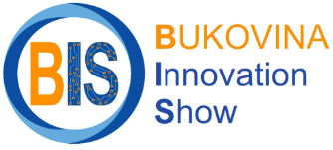



Xth International Fair of Innovation and Creative Education for Youth
SUCEAVA, ROMANIA
May 25 – 27, 2026
Name of the institution:
Country:
Contact person:
E-mail/ Mobile Phone:
Number of participating inventions/ projects:

Invention/ Project title (EN):*
.................
Authors:
.................
Patent no.:
...................
Description (EN) (maximum 2 pages, TNR 12, 1.15 line space):
..................
*Please complete a separate table for each invention/ project

Number of participating persons in the BIS event
(on-site): .................
Name and surname | Arrival  date | Departing date | Acommodation**  Yes/ No | Official dinner  (26.05.2026)  Yes/ No
1.
2.
3.
.....

** Accommodation will be in student dormitories (located in university campus No. 1) in a room with two separate beds.

Would you like to register for the 10-InSTED workshop? | YES/ NO
Title:

Please send form to costel@usm.ro before 30 April 2026.

